**Notes:**

1. This document contains the instruction and questions that you need to answer for:
   1. The Packet Tracer activity named wk13-computer-prac-PKA-b-Show-Commands.pka
   2. The Packet Tracer activity named wk13-computer-prac-PKA-c-Explore-Network.pka
2. When doing each of the two Packet Tracer activities,
   1. Follow the instruction in **this** Word document to complete the Packet Tracer activity.
   2. Type in your answer to EACH question included in this document, immediately after the question in the space provided.
3. Save this Word document and submit it as part of your Week 13 Computer Practical submission.

****Packet Tracer - Using Show Commands****

1. Note:
2. 1. Download from Learnonline course website (Computer Practical-Week 13 folder) the Packet Tracer activity file: wk13-computer-prac-PKA-b-Show-Commands.pka
3. 2. Open the Packet Tracer activity file downloaded
4. 3. Follow the instruction given below to complete this Packet Tracer activity and type your answers to the questions in the spaces provided.
5. Objectives

Part 1: Analyze Show Command Output

Part 2: Reflection Questions

1. Background

This activity is designed to reinforce the use of router **show** commands. You are not required to configure, but rather examine the output of several **show** commands.

1. Analyze Show Command Output
   1. Connect to ISPRouter
      1. Click **ISP PC**, then the **Desktop** tab, followed by **Terminal**.
      2. Enter privileged EXEC mode.
      3. Use the following **show** commands to answer the Reflection Questions in Part 2:

show arp

show flash:

show ip route

show interfaces

show ip interface brief

show protocols

show users

show version

1. Reflection Questions
   1. Which commands would provide the IP address, network prefix, and interface?

Your answer: show ip route, show protocols (before IOS 15, the show ip route command did not display the IP address of the interfaces)

* 1. Which commands provide the IP address and interface assignment, but not the network prefix?

Your answer: show ip interface brief

* 1. Which commands provide the status of the interfaces?

Your answer: show interfaces, show ip interface brief

* 1. Which commands provide information about the IOS loaded on the router?

Your answer: show version

* 1. Which commands provide information about the addresses of the router interfaces?

Your answer: show arp, show interfaces

* 1. Which commands provide information about the amount of and Flash memory available?

Your answer: show version, show flash

* 1. Which commands provide information about the lines being used for configuration or device monitoring?

Your answer: show users

* 1. Which commands provide traffic statistics of router interfaces?

Your answer: show interfaces

* 1. Which commands provide information about paths available for network traffic?

Your answer: show ip route

* 1. Which interfaces are currently active on the router?

Your answer: GigabitEthernet 0/0, Serial 0/0/1

Packet Tracer - Explore a Network

1. Note:
2. 1. Make sure Packet Tracer has been installed.
3. 2. Download from Learnonline course website (Computer Practical-Week 13 folder) the Packet Tracer activity file: wk13-computer-prac-PKA-c-Explore-Network.pka
4. 3.Open the Packet Tracer activity file downloaded
5. 4. Follow the instruction given below to complete this Packet Tracer activity and type your answers to the questions in the spaces provided.
6. Topology

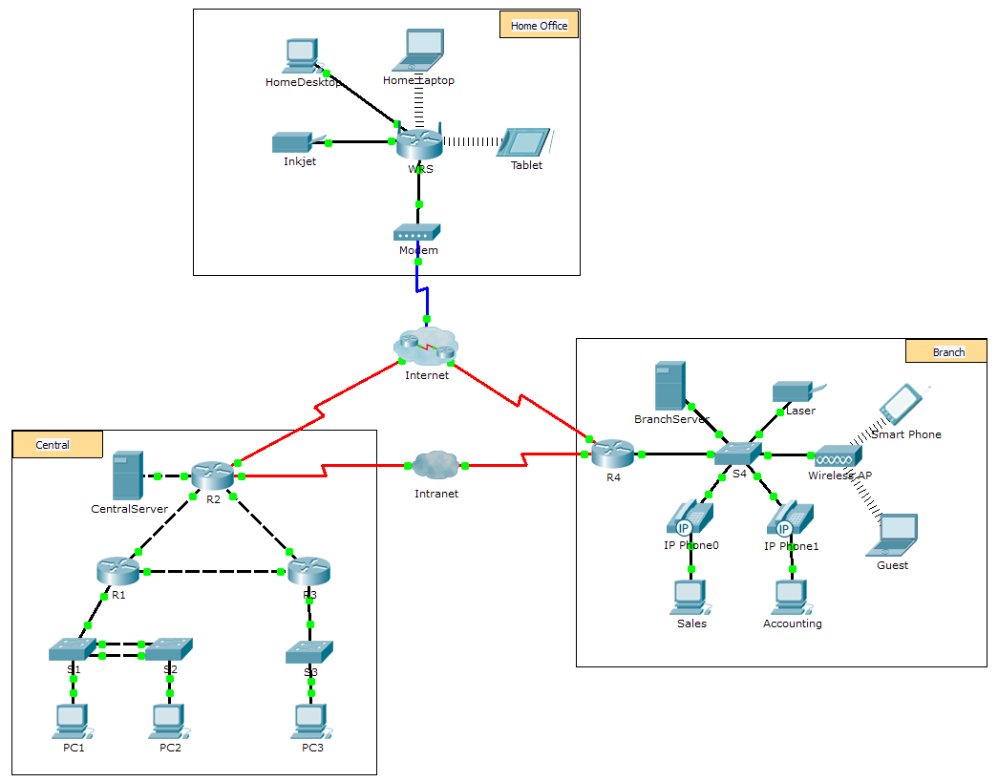

1. Objectives

Part 1: Examine Internetwork Traffic at Branch

Part 2: Examine Internetwork Traffic to Central

Part 3: Examine Internet Traffic from Branch

1. Background

This simulation activity is intended to help you understand the flow of traffic and the contents of data packets as they traverse a complex network. Communications will be examined at three different locations simulating typical business and home networks.

Take a few moments to study the topology displayed. The Central location has three routers and multiple networks possibly representing different buildings within a campus. The Branch location has only one router with a connection to both the Internet and a dedicated wide-area network (WAN) connection to the Central location. The Home Office makes use of a cable modem broadband connection to provide access to both the Internet and to corporate resources over the Internet.

The devices at each location use a combination of static and dynamic addressing. The devices are configured with default gateways and Domain Name System (DNS) information, as appropriate.

Additionally, the network model in this activity incorporates many of the technologies that you have learned in this course (and that you would learn in following networking courses). It represents a simplified version of how a small to medium-sized business network might look. Feel free to explore the network on your own.

1. Examine Internetwork Traffic at Branch

In Part 1 of this activity, you will use Simulation mode to generate web traffic and examine the HTTP protocol along with other protocols necessary for communications.

* 1. Switching from Realtime to Simulation mode.
     1. Click the **Simulation** mode icon to switch from **Realtime** mode to **Simulation** mode.
     2. Verify that **ARP, DNS, HTTP**,and **TCP** are selected from the **Event List Filters**.
     3. Move the slider located below the **Play Controls** buttons (**Back**, **Auto Capture**/**Play**, **Capture**/**Forward**) all the way to the right.
  2. Generate traffic using a web browser.

Currently the Simulation Panel is empty. In the Event List at the top of the Simulation Panel there are six columns listed across the heading. As traffic is generated and stepped through, events display in the list. The **Info** column is used to inspect the contents of a particular event.

**Note**: The panel to the left of the Simulation Panel displays the topology. Use the scrollbars to bring the Branch location into the panel, if necessary. The panels can be adjusted in size by hovering next to the scrollbar and dragging left or right.

* + 1. Click the **Sales PC** in the far left pane.
    2. Click the **Desktop** tab and click the **Web Browser** icon to open it.
    3. In the URL field, enter **http://branchserver.pt.pta** and click **Go**. Look in the Event List in the Simulation Panel. What is the first type of event listed?

Your answer: The DNS request for the IP address of branchserver.pt.pta.

* + 1. Click the **DNS** info box. In the **Out Layers**, DNS is listed for Layer 7. Layer 4 is using UDP to contact the DNS server on port 53 (**Dst Port:**). Both the source and destination IP addresses are listed. What information is missing to communicate with the DNS server?

Your answer: The Layer 2 information, specifically the destination MAC address.

* + 1. Click **Auto Capture/Play**. In approximately 30 to 40 seconds, a window displays, indicating the completion of the current simulation. (Or a window may display indicating that the buffer is full.) Click the **View Previous Events** button. Scroll back to the top of the list and note the number of **ARP** events. Looking at the Device column in Event list, how many of the devices in the Branch location does the **ARP** request pass through?

Your answer: Each device received an ARP request.

* + 1. Scroll down the events in the list to the series of **DNS** events. Select the **DNS** event that has the “At Device” listed as **BranchServer**. Click the square box in the **Info** column. What can be determined by selecting Layer 7 in the **OSI Model**? (Look at the results displayed directly below **In Layers.**)

Your answer: The DNS server receives a DNS query. The name queried resolved locally.

* + 1. Click the **Outbound PDU Details** tab. Scroll to the bottom of the window and locate the DNS Answer section. What is the address displayed?

Your answer: 172.16.0.3, the address of Branchserver.

* + 1. The next several events are **TCP** events enabling a communications channel to be established. Select the last **TCP** event at device **Sales** just prior to the **HTTP** event. Click the colored square Info box to display the PDU information. Highlight Layer 4 in the **In Layers** column. Looking at item 6 in the list directly below the **In Layers** column, what is the connection state?

Your answer: Established

* + 1. The next several events are **HTTP** events. Select any one of the **HTTP** events at an intermediary device (IP Phone or Switch). How many layers are active at one of these devices, and why?

Your answer: Two layers, because these are Layer 2 devices.

* + 1. Select the last **HTTP** event at the Sales PC. Select the uppermost layer from the **OSI Model** tab. What is the result listed below the **In Layers** column?

Your answer: The HTTP client receives a HTTP reply from the server. It displays the page in the web browser.

1. Examine Internetwork Traffic to Central

In Part 2 of this activity, you will use Packet Tracer (PT) Simulation mode to view and examine how traffic leaving the local network is handled.

* 1. Set up for traffic capture to the Central web server.
     1. Close any open PDU Information windows.
     2. Click **Reset Simulation** (located near the middle of the Simulation Panel).
     3. Type **http://centralserver.pt.pta** in the web browser of the Sales PC.
     4. Click **Auto Capture/Play**; in approximately 75 seconds, a window displays, indicating the completion of the current simulation. Click **View Previous Events**. Scroll back to the top of the list; note that the first series of events are **DNS** and there are no **ARP** entries prior to contacting the **BranchServer**. Based on what you have learned so far, why is this the case?

Your answer: The Sales PC already knows the MAC address of the DNS server.

* + 1. Click the last DNS event in the **Info** column. Select **Layer 7** in the **OSI Model** tab.

By looking at the information provided, what can be determined about the DNS results?

Your answer: The DNS server was able to resolve the domain name for centralserver.pt.pta.

* + 1. Click the **Inbound PDU Details** tab. Scroll down to the **DNS ANSWER** section. What is the address listed for centralserver.pt.pta?

Your answer: 10.10.10.2

* + 1. The next several events are **ARP** events. Click the colored square Info box of the last **ARP** event. Click the **Inbound PDU Details** tab and note the MAC address. Based on the information in the ARP section, what device is providing the ARP reply?

Your answer: The R4 Router, the gateway device.

* + 1. The next several events are **TCP** events, once again preparing to set up a communications channel. Find the first **HTTP** event in the Event List. Click the colored square box of the **HTTP** event. Highlight Layer 2 in the **OSI Model** tab. What can be determined about the destination MAC address?

Your answer: It is the MAC Address of the R4 router.

* + 1. Click the **HTTP** event at device **R4**. Notice that Layer 2 contains an Ethernet II header. Click the **HTTP** event at device **Intranet**. What is the Layer 2 listed at this device?

Your answer: Frame Relay FRAME RELAY.

1. Examine Internet Traffic from Branch

In Part 3 of this activity, you will clear the events and start a new web request that will make use of the Internet.

* 1. Set up for traffic capture to an Internet web server.
     1. Close any open PDU information windows.
     2. Click **Reset Simulation** near the middle of the Simulation Panel. Type **http://www.netacad.pta** in the web browser of the Sales PC.
     3. Click **Auto Capture/Play**; in approximately 75 seconds, a window displays, indicating the completion of the current simulation. Click **View Previous Events**. Scroll back to the top of the list; notice that the first series of events are **DNS**. What do you notice about the number of **DNS** events?

Your answer: There are considerably more DNS events. Because the DNS entry is not local it is forwarded to a server on the Internet.

* + 1. Observe some of the devices that the **DNS** events travel through on the way to a DNS server. Where are these devices located?

Your answer: In the Internet Cloud, students should be shown that those devices can be displayed by clicking the cloud and then clicking the Back link to go back.

* + 1. Click the last **DNS** event. Click the **Inbound PDU Details** tab and scroll down to the last DNS Answer section. What is the address listed for **www.netacad.pta**?

Your answer: 216.146.46.11

* + 1. When routers move the **HTTP** event through the network, there are three layers active in both the **In Layers** and **Out Layers** in the **OSI Model** tab. Based on that information, how many routers are passed through?

Your answer: There are 3 routers (ISP-Tier3a, ISP-Tier3b and R4), however there are 4 HTTP events travelling through the routers.

* + 1. Click the **TCP** event just prior to the last **HTTP** event. Based on the information displayed, what is the purpose of this event?

Your answer: To close the TCP connection to 216.146.46.11.

* + 1. There are several more **TCP** events listed. Locate the **TCP** event where the *Last Device* is **IP Phone** and the *Device At* is **Sales**. Click the colored square Info box and select **Layer 4** in the **OSI Model** tab. Based on the information from the output, what is the connection state set to?

Your answer: Closing